Parameterization using Data Table:--



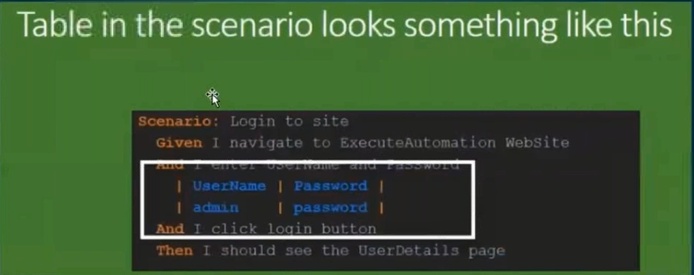

Note:--

1. Always first Row is identified as Column Names.
2. Always Column Name ,must start with Lower Case.
3. This Approach cannot be used to Iterate multiple values to a single Column.,
4. Used to pass single value to multiple Columns.

Login2.feature

**Feature:** Store login

This feature deals with the login functionality.

**Scenario:** Login with correct username and correct password using DataTable

Given I navigate to login page

#When I entered username and password

#When I entered "admin1" and "pass1"

*When* I entered following details

| userName | passWord |

| admin | adminpass |

*And* I clicked signin button

*Then* Its navigated to the home page

-------

package stepDefinition;

import java.util.ArrayList;

import java.util.List;

import cucumber.api.DataTable;

import cucumber.api.java.en.And;

import cucumber.api.java.en.Given;

import cucumber.api.java.en.Then;

public class stepDef_Datatable {

@Given("^I navigate to login page")

public void navigateToLoginPage(){

System.out.println("Navigated to the Login Page");

}

@Then("^Its navigated to the home page")

public void navigateToHomePage(){

System.out.println("Navigated to the Home Page");

}

@And("^I clicked signin button")

public void clickSigninButton(){

System.out.println("clicked signin button");

}

@When("^I entered following details")

public void enterUsernamePassword(DataTable table){

List<List<String>> data = table.cells();

System.out.println(" 1st coulumn is - "+ data.get(0).get(0));

System.out.println(" 2nd column is - "+ data.get(0).get(1));

System.out.println(" username is - "+ data.get(1).get(0));

System.out.println(" password is - "+ data.get(1).get(1));

}

--

=================================================================================

Scenario outline :---

This is used to Iterate multiple values of a single Column.



Login_parameter_scenarioOutline.feature:--

------------------------

Feature: Store login

This feature deals with the login functionality.

Scenario Outline: Login with correct username and correct password

Given I navigate to login page

#And I entered username and password

When I insert "<userName>" and "<passWord>"

And I clicked signin button

Then Its navigated to the home page

Examples:

| userName | passWord |

| admin1 | admin12 |

| admin2 | admin22 |

| admin3 | admin33 |

stepDef_Datatable.java:--

package stepDefinition;

import java.util.ArrayList;

import java.util.List;

import cucumber.api.DataTable;

import cucumber.api.java.en.And;

import cucumber.api.java.en.Given;

import cucumber.api.java.en.Then;

public class stepDef_Datatable {

@Given("^I navigate to login page")

public void navigateToLoginPage(){

System.out.println("Navigated to the Login Page");

}

@Then("^Its navigated to the home page")

public void navigateToHomePage(){

System.out.println("Navigated to the Home Page");

}

@And("^I clicked signin button")

public void clickSigninButton(){

System.out.println("clicked signin button");

}

//@When("I insert \"([^\"]*)\" and \"([^\"]*)\"")

@When("I insert {string} and {string}")

**public** **void** enterUsernamePassword(String username , String password)

{

System.***out***.println("username :"+username);

System.***out***.println("password :"+password);

}

}